Website Manual Evaluation Summary

Name of website:  URL of website:  College/Department/Unit: | Name of evaluator:  Browser/Version used:  Date of assessment:  Tools used: | Tool suggestions  - Link Klipper  - Colour Contrast Analyser  - Chrome High Contrast
Note: This document is based on the CSU 2018 Web Performance Manual Evaluation Work Sheet
Type of test | Check Point (if applicable) | Resources | Comments (what did you observe?) | Fail/Pass/NA
Is there a link to an Accessibility Statement on this page? If so, provide the link in the comments section. | 603.2 Information on Accessibility and Compatibility Features. ICT support services shall include information on the accessibility and compatibility features required by 602.2. | Accessibility Statement Recommendations  Highlights:  - Commitment  - process for assuring compliance  - overall level of compliance  - compatibility issues with Browsers  - Support Documentation and Services  - Accessibility short cuts specific to programs  - Report system for feedback  - Known barriers  - Known workarounds  - Projected resolutions
From the users perspective, is the navigation theme consistent for this page in relationship to campus web environment or the department or functional area the page is found within? Does it appears to be expected and understandable behavior? | Guideline 3.2 Predictable: Make Web pages appear and operate in predictable ways. | 3.2.3 Consistent Navigation (Level AA)
Keyboard Operable  --tab through, look for visual focus and consistent behavior as you tab through for menus etc. Consist marking of links, e.g. Bold underline.  Remember to check any video players on the site | G202 Keyboard Operable (WCAG 2)  G149 Visual Focus | New:  - WebAIM Standard keyboard operability  - G202: Ensuring keyboard control for all functionality  - Quick Reference Operable section- navigate to Keyboard Operable  - W3C Visible Focus  - Understanding Success Criterion 1.4.10: Reflow  Simple example: Controlled visual Focus Example (not browser dependent): Deque: Designing usable focus indicators  Additional Resources:  UDC Web criteria – Keyboard Accessibility
Keyboard Traps  --Do you get stuck, i.e. in video player or somewhere in a form on a page? | F10a Keyboard Traps (WCAG 2)  Related to G107 Unexpected behavior | Examples:  - Problem example of tabbing getting stuck: Interactive Accessibility - Training Example  - Unexpected behavior example – and Keyboard Trap - as you tab into the form it auto activates into the link without you actually selecting it.  UDC Web criteria – Keyboard Traps  Related Resources:  F10 Failure of Success Criterion 2.1.2  WCAG 2.0 No Keyboard trap  WCAG Non-Interference
Tab Order  --Tabbing through the page, does it follow a logical order? | G59a Default Tab Order (WCAG 2) | I.E. toolbar plug in from Vision Australia can be used to expose the tab order using Structure, Tab Order Indicator  UDC Web Criteria Keyboard accessibility- example tab order  G59: Placing the interactive elements in an order that follows sequences and relationships within the content
Scrolling Content  --Pause, stop, navigate | F16 Failure of Success Criterion 2.2.2 due to including scrolling content where movement is not essential to the activity without also including a mechanism to pause and restart the content. (WCAG 2) | UDC Web accessibility criteria- screen movement  WCAG F16 Scrolling Content
Resize screen: Zoom to 200% | 1.4.4 Resize Text | From your browser’s Tools menu, usually found in the Zoom portion of the menu, adjust to 200%  Understanding Success Criterion 1.4.4: Resize text  WCAG Examples Success Criteria 1.4.4
Link text  --Does it tell you where it will lead you? The reader should be able to discern the purpose of each link from the link text alone. Typically Link text will match somewhat to the Web Page Title it goes to and the H1 of that page  To Do: Extract all the links and link text from the page.  Are they understandable? | G91 Link text describes link purpose 2.4.4 Link Purpose (In Context)  Level A (WCAG 2) under the Header “Examples” it explains 5 ways to achieve this standard  Understanding Success Criterion 2.4.9: Link Purpose (Link Only) Level AAA  Techniques for tagging vague often times redundant link text such as “read more”, “more”, “more info” Example: ARIA8: Using aria-label for link purpose  H33: Supplementing link text with the title attribute | Link Klipper - Extract all links - Chrome Web Store  Level A: Can you understand where each link will leads to? If yes, than that pass. If no, than check to see if the vague link text, e.g. “Read More” is within a sentence ending with a period or a paragraph. If yes, than pass.  W3C Schools HTML Links  G91 Providing link text that describes purpose of link  UDC Web accessibility criteria-link text
Page Title  When you open the web page, does a meaningful Title appear in the tab? | G88 A descriptive title allows a user to easily identify what Web page they are using | UDC Web accessibility criteria- Example of descriptive page title  WCAG G88 Providing descriptive titles Web page
Document Language for a page being declared helps a screen readers to read the content in the appropriate language. Also helps with automatic translation of content | 3.1.1 Language of Page: The default human language of each Web page can be programmatically determined. | When using the WAVE toolbar a call out bubble will appear to signify the Error -  Document language missing  A more technical way to check the lang of the document is the view the source code and search for lang=" ". Such as lang="en-US"
Headers  --Are they in order?  Is there a clear hierarchy of the order that matches the visual display? For example, Header 1 is more important than Header 2 and this importance is matched in the visual display such as size of text. In other words, bigger text is more important than smaller text. | H42a Use h1-h6 to identify headings (WCAG 2) | Wave toolbar helpful hints  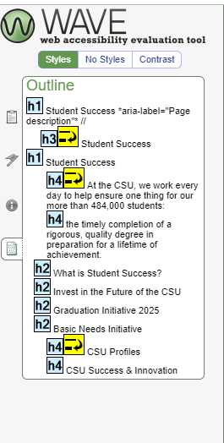  Figure 1The WAVE toolbar can expose the Header structure using the Outline feature on the report.  UDC Web Criteria –Semantic Req - see H1-H6 Heading Examples  WCAG Using H1-H6 to identify headings
Data Tables  --Proper mark up?  --Is a caption provided for the table? | H51a Use table markup to present tabular information (WCAG2)  H43 Use id and headers attributes to associate data cells with header cells in data tables (WCAG2) | Tables Concepts  Caption and Summary  UDC Web Criteria- Tables  WCAG H51: Using table markup to present tabular information
Tables used for layout  --not advisable | F49 – layout tables must linearize | From your browser’s Tools menu  - Interactive Accessibility – Training examples- Inaccessible Layout Tables  Use the Web Developer toolbar under Miscellaneous and select Linearize page to see how the content is out of order when a table is used for layout and read by a screenreader  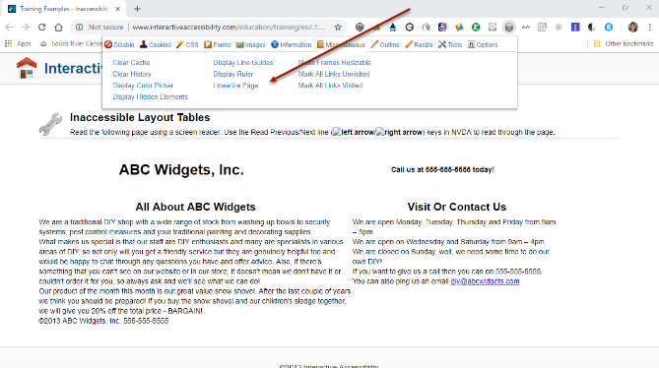  UDC Web Criteria – tables – see examples for layout tables  WCAG Failure of table linearization
Optional:  Are abbreviations used on the page? Are they defined or it is assumed the reader knows them?  While this may not be a required standard at this time, it is helpful to all users. This is NOT a WCAG AA standard but it is helpful for all types of users and is a best practice for Universal Design. | G102: Providing the expansion or explanation of an abbreviation | G97: Providing the first use of an abbreviation immediately before or after the expanded form |  | No P/F/NA due to WCAG AAA being Optional
If there are images on a webpage consider if these images are conveying meaning. If alternative text is used, it should NOT provide more information than what a sighted person would get. Any information that is additional information should be available to everyone. For example, the name of a person in a photo would be placed in the caption. Hiding it in the alt text makes it only available to some. | Guideline 1.1 Text Alternatives: Provide text alternatives for any non-text content | Informative Images  Webaim  1.1.1 Non-text Content (Level A)  1.4.5 Images of Text: If the technologies being used can achieve the visual presentation, text is used to convey information rather than images of text except for the following: (Level AA)
If forms are used on the page, address the following:  Automated testing tools can be used to alert web developers to improper coding of form fields, but it cannot tell you if the Error Messaging is understandable to the human reader. Therefore this manual check consists of filling out the form and seeing if you understand what the error message is telling the user and if the user is driven to the form field to correct it or simply told the number of errors and the names of the fields which are incorrectly filled out or missing.  Form fields should be coded to be related to the Label or text next to them, e.g. Last Name. Automated evaluation tools such as Compliance Sheriff will identify any form fields that are coded incorrectly or not coded at all. Therefore form field labeling does not need to be part of the manual evaluation.  Required fields should be marked to let users know they are required input fields without relying on color. Typically this is done with an “*”. A meaningful error message should be provided to the user if the form field is left blank or filled out incorrectly. This can be achieve a number of ways.  When the user types letters in a number field the user is provided a message immediately.  Form fields which are incorrectly filed out also need meaningful messages to the user. | Guideline 3.3 Input Assistance: Help users avoid and correct mistakes. | Detailed information regarding the elements on a form are listed below.  Overview of what to look for:  - For more complicated forms overall instructions are helpful to describe to all users the purpose of the form and that Required fields are clearly indicated for all users, e.g. required marked with “*”  - Does each form have a label the makes since, e.g. “Name”.  - Error prevention-  - Can users review their form entries before submission?  - Can they undo their Submission?  - Are users alerted to data entry errors, e.g. incorrectly inputting date. This data is checked for input errors and the user is provided an opportunity and the information needed to correct them, e.g. “Enter date in the following format MM/DD/YYYY”.  - A mechanism is available for reviewing, confirming, and correcting information before finalizing the submission.  Form Instructions  Validating Input  User Notifications  Multi-page Forms  W3C Accessible Survey Page  - Before and After Demonstration  WC3 Input Assistance
In addition to checking for Color Contrast within an automated evaluation tool such as Compliance Sheriff, there are many elements on a web page that require manual checking to consider how color is being presented to the user. Some users may be color blind or not perceive color in the same way that you do. In order to allow everyone to enjoy the information on a web page to a usable extent, we need to consider contrast ratio as we design web pages. You cannot be expected to know the actual contrast ratio as a computer would, but as a user you may notice issues during the keyboard focus manual checking that require additional investigation. These may require the assistance of a web developer skilled in CSS to Resolve. | G145 Ensure contrast ratio is adequate (ratio of at least 3:1) G18 Ensure contrast ratio (ratio of at least 4.5:1)  Understanding Success Criterion 1.4.3: Contrast (Minimum) | Lighthouse Guild provides a view of their webpage resources in different color combinations. On the top menu, “Change Color” provides a view of the page with various color combinations.  Color and Contrast on Web Pages  Chrome High Contrast  Colour Contrast Analyser allows for testing color manually.  Advanced examples:  Sample page of “Simple” contrast examples  Sample page of Variation of contrast configurations
Is there Multimedia on the page?  If so, if there are spoken words or utterances, these should be captioned for prerecorded or live streamed media.  Don’t forget to check the media player of the video or materials for keyboard access. | Time based Media  Guideline 1.2 Time-based Media: Provide alternatives for time-based media.  Audio Description (Prerecorded):  Understanding SC 1.2.5 | Example of captioning only: Smart Player Overview  Example: Audio Description - CaptionSync by Automatic Sync Next to the CC button there is an “AD” button. Turn it on to hear both the spoken word and a visual description. There is also a transcript of both spoken word and visual description.
Is a mechanism provided to bypass blocks of content that are repeated on multiple Web pages? | Guideline 2.4.1 Bypass Blocks | Example of “Skip Navigation” Link (Level A)
All pages that have links to files that require a special reader (e.g. Adobe Reader) or plug-in are required to contain the specified text indicating a link to the reader or plug-in. | CSU 6.3.8 | The CSU ATI Accessibility Requirements – CSU 6. 3.8 Long Description When some proprietary file formats are used, add-ons or plug-ins are required to display special content. Therefore, link to a plug-in should be provided for download in order to view the content on all web browsers.

Overall questions regarding the page evaluation.
Please list a summary of action (s) needed and the status of those actions.
Action needed:

Action taken:

